Questions
Q1.
A student in the northern hemisphere observed the times of sunrise and sunset for a week.
Figure 5 shows the results.
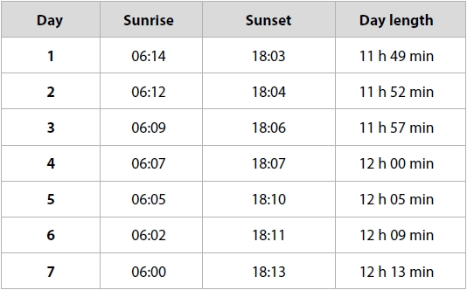
Figure 5
Analyse the data in Figure 5 to determine the date of Day 4.
(3)
.............................................................................................................................................
.............................................................................................................................................
.............................................................................................................................................
.............................................................................................................................................
.............................................................................................................................................
.............................................................................................................................................

(Total for question = 3 marks)

Q2.
An astronomer on board a ship took measurements of the Sun to measure the ship's latitude.
These measurements are shown in Figure 6 below.
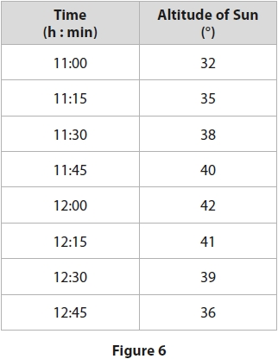
The astronomer also looked up the declination of the Sun, which was 8°.
The astronomer used these measurements to make the following conclusion.
The Sun is at 42° when it is at its highest point.
This means that latitude = 42° - 8°
So, the ship's latitude = 34°
The astronomer's ship has been sailing for several days.
When it is local noon at the ship's location, an accurate clock on board shows that it is 13:20 at its home port.
(i) Calculate how many degrees of longitude the ship has covered since leaving its home port.
(2)
Answer = ........................................................... °
The ship's home port has a longitude of 130° W.
(ii) Calculate the ship's current longitude.
(2)
Answer = ...........................................................

(Total for question = 4 marks)

Q3.
Figure 7 shows a recent 'supermoon'.
A 'supermoon' can occur only when the Moon is at the point in its orbit where it is closest to the Earth.
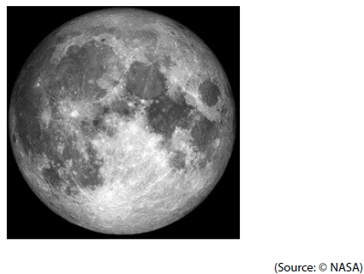
Figure 7
(i) How many days after this photograph will it be until the next full Moon?
Give your answer to 1 decimal place.
(1)
.............................................................................................................................................
(ii) How many days after this photograph will it be until the Moon is next at its closest to the Earth?
Give your answer to 1 decimal place.
(1)
.............................................................................................................................................

(Total for question = 2 marks)

Q4.
Answer the questions with a cross in the boxes you think are correct . If you change your mind about an answer, put a line through the box and then mark your new answer with a cross .
(i) A star that is circumpolar from a certain location will:
(1)
A Always be visible
B Always be below the horizon
C Always be above the horizon
D Always be at the observer's zenith
(ii) The Autumnal Equinox takes place on or close to:
(1)
A 21st March
B 21st June
C 21st September
D 21st December

(Total for question = 2 marks)

Q5.
Figure 7 shows a recent 'supermoon'.
A 'supermoon' can occur only when the Moon is at the point in its orbit where it is closest to the Earth.
Figure 7
An observer wishes to make some naked-eye drawings to illustrate the effect of libration.
Design a suitable observing programme that will allow the observer to produce a series of drawings that show clearly the effect of libration.
(6)
.............................................................................................................................................
.............................................................................................................................................
.............................................................................................................................................
.............................................................................................................................................
.............................................................................................................................................
.............................................................................................................................................
.............................................................................................................................................
.............................................................................................................................................
.............................................................................................................................................
.............................................................................................................................................
.............................................................................................................................................
.............................................................................................................................................

(Total for question = 6 marks)

Q6.
Answer the question with a cross in the boxes you think are correct . If you change your mind about an answer, put a line through the box and then mark your new answer with a cross .
(i) Which of the following is a constellation?
(1)
A Cassiopeia
B Orion's Belt
C Sirius
D Summer Triangle
(ii) Which of the following is equal to one year?
(1)
A The time for the Earth to rotate once
B The time for the Moon to orbit the Earth
C The time for the Sun to rotate once
D The time for the Earth to orbit the Sun
(iii) Which of the following gives the highest water level?
(1)
A Low tide
B Neap tide
C Spring tide
D Winter tide

(Total for question = 3 marks)

Q7.
A lunar eclipse can occur at which of these phases?
A First Quarter
B Full
C Last Quarter
D New

(Total for question = 1 mark)

Q8.
The Sun crosses the Celestial Equator on the:
A 1st January
B 21st March
C 21st June
D 21st December

(Total for question = 1 mark)

Q9.
All the planets in the Solar System have both a sidereal and synodic period.
(i) Generally, the sidereal period of the superior planets is larger than their synodic period.
Explain why the sidereal period would be larger than the synodic period.
(3)
.............................................................................................................................................
.............................................................................................................................................
.............................................................................................................................................
.............................................................................................................................................
.............................................................................................................................................
.............................................................................................................................................
(ii) An astronomer claims to have discovered an object that orbits the Sun at a mean distance of 500 AU.
The astronomer thinks that the synodic period is close to 1 year.
Explain why the synodic period for this object would be close to 1 year.
(2)
.............................................................................................................................................
.............................................................................................................................................
.............................................................................................................................................
.............................................................................................................................................

(Total for question = 5 marks)

Q10.
A student made some naked-eye observations of the night sky.
Sketch how the Moon appears in the northern hemisphere, three days after the new moon.
(1)

(Total for question = 1 mark)

Q11.
Figure 3 shows a star map of the area around the constellation of Gemini.
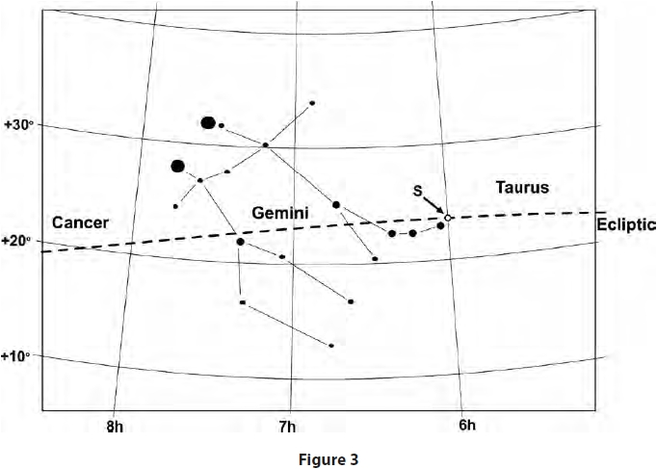
The ecliptic passes through this area of the sky.
On 21st June, the Sun reaches the most northerly point on the ecliptic, labelled 'S' in Figure 3.
State the astronomical name given, in the northern hemisphere of the Earth, to the day when the Sun is at 'S'.
(2)
.............................................................................................................................................

(Total for question = 2 marks)

