Questions
Q1.
An astronomer made observations of the night sky from Edinburgh at midnight GMT in July.
Edinburgh has a latitude of 55°57&#697; N and a longitude of 3°15&#697; W.
Figure 9 shows data for three stars the astronomer observed.
At the time of the observation, Vega was due south on the observer's meridian.
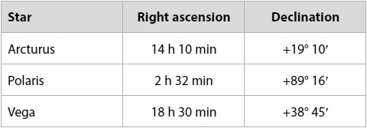
Figure 9
Analyse the data in Figure 9 in order to explain the difference in the paths through the night sky of Vega and Arcturus, when observed from Edinburgh.
(3)
.............................................................................................................................................
.............................................................................................................................................
.............................................................................................................................................
.............................................................................................................................................
.............................................................................................................................................
.............................................................................................................................................

(Total for question = 3 marks)

Q2.
An astronomer observing from Rome sees the star Aldebaran setting. The local sidereal time (LST) is 10:42 and the star's hour angle (HA) is 06h 06min.
Rome has a latitude of 42°N and a longitude of 12°30'E.
The astronomer contacts a colleague in Oxford and tells her the right ascension (RA) and declination (Dec) of Aldebaran.
Oxford has a latitude of 51° 45' N and a longitude of 1° 15' W.
Calculate the highest altitude that the star Aldebaran will reach, as seen by the astronomer in Oxford.
(2)
Altitude = ................................ ° ................................'

(Total for question = 2 marks)

Q3.
Figure 3 shows a star map of the area around the constellation of Gemini.
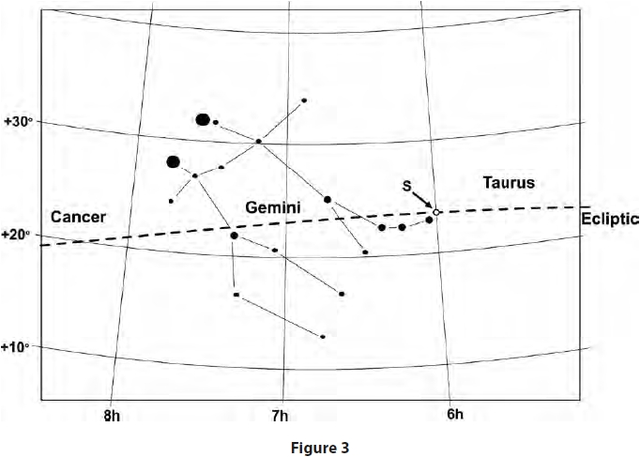
The ecliptic passes through this area of the sky.
On 21st June, the Sun reaches the most northerly point on the ecliptic, labelled 'S' in Figure 3.
Alice decides to observe the Sun throughout the day on June 21st.
Her location has a latitude of 23¹⁄₂° N.
Describe how the Sun appears to move across the sky from Alice's location on June 21st.
You may include a carefully labelled diagram in your answer.
(2)
.............................................................................................................................................
.............................................................................................................................................
.............................................................................................................................................

(Total for question = 2 marks)

Q4.
An astronomer made observations of the night sky from Edinburgh at midnight GMT in July.
Edinburgh has a latitude of 55°57&#697; N and a longitude of 3°15&#697; W.
Figure 9 shows data for three stars the astronomer observed.
At the time of the observation, Vega was due south on the observer's meridian.
Figure 9
(i) Determine the altitude and azimuth of the star Polaris at the time of this observation.
Give your answers to the nearest degree.
(2)
Altitude
.............................................................................................................................................
Azimuth
.............................................................................................................................................
(ii) Determine the altitude of Vega at the time of this observation.
(2)
.............................................................................................................................................
.............................................................................................................................................
.............................................................................................................................................
(iii) Determine the sidereal time at Greenwich at the time of this observation.
(3)
.............................................................................................................................................
.............................................................................................................................................
.............................................................................................................................................
.............................................................................................................................................
.............................................................................................................................................

(Total for question = 7 marks)

Q5.
(i) Explain why light pollution may affect some naked-eye observations of constellations.
(2)
.............................................................................................................................................
.............................................................................................................................................
.............................................................................................................................................
.............................................................................................................................................
(ii) A student begins an observation at midnight on a clear moonless winter night.
Explain why the student notices that more stars are visible half an hour later.
(2)
.............................................................................................................................................
.............................................................................................................................................
.............................................................................................................................................
.............................................................................................................................................

(Total for question = 4 marks)

Q6.
Figure 5 shows part of a star map from the area around the constellations Ursa Major and Ursa Minor.
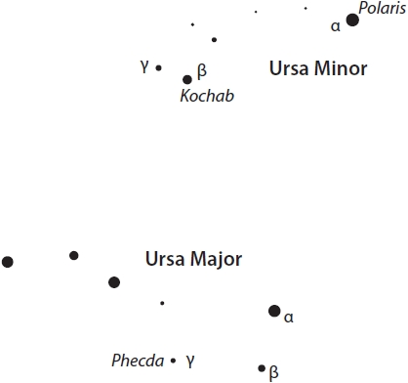
Figure 5
Two of the brightest stars in Figure 5 are Phecda (γ in Ursa Major) and Kochab (β in Ursa Minor). Their coordinates are shown in Table 1.
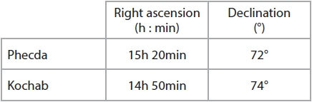
Table 1
The Ancient Egyptians referred to these two stars as the 'Eternal' or 'Immortal' ones.
Egypt has a latitude of around 30°N.
Explain, using astronomical information from Table 1, why they gave them this name.
.............................................................................................................................................
.............................................................................................................................................
.............................................................................................................................................
.............................................................................................................................................
.............................................................................................................................................
.............................................................................................................................................

(Total for question = 3 marks)

Q7.
(i) When observing from a latitude of 50°N on the Earth, the Pole Star will appear to have an altitude of:
(1)
A 0°
B 40°
C 50°
D 90°
(ii) When observing from a latitude of 50°N on the Earth, the Celestial Equator will have a maximum altitude of:
(1)
A 0°
B 40°
C 50°
D 90°

(Total for question = 2 marks)

Q8.
An astronomer observing from Rome sees the star Aldebaran setting. The local sidereal time (LST) is 10:42 and the star's hour angle (HA) is 06h 06min.
Rome has a latitude of 42°N and a longitude of 12°30'E.
Show that Aldebaran has a right ascension (RA) of 04h 36min.
Use the observational data given above.
Include a carefully labelled diagram in your answer.
(3)
.............................................................................................................................................
.............................................................................................................................................
.............................................................................................................................................
.............................................................................................................................................

(Total for question = 3 marks)

Q9.
An astronomer observing from Rome sees the star Aldebaran setting. The local sidereal time (LST) is 10:42 and the star's hour angle (HA) is 06h 06min.
Rome has a latitude of 42°N and a longitude of 12°30'E.
The astronomer waits until Aldebaran is due south and measures its angle above the horizon as 64° 30'.
Show that Aldebaran has a declination (Dec) of 16° 30'.
Use the observational data given above.
Include a carefully labelled diagram in your answer.
(2)
.............................................................................................................................................
.............................................................................................................................................
.............................................................................................................................................
.............................................................................................................................................

(Total for question = 2 marks)

