Questions
Q1.
Answer the questions with a cross in the boxes you think are correct . If you change your mind about an answer, put a line through the box and then mark your new answer with a cross .
A sundial in the United Kingdom shows 11:15 am on a day when the Equation of Time is -6 minutes.
The sundial's longitude is 3° W.
These observations mean that:
(i) A clock at the sundial's location would show:
(1)
A 11:15
B 11:21
C 11:27
D 11:33
(ii) Greenwich Mean Time is:
(1)
A 11:15
B 11:21
C 11:27
D 11:33
(iii) The Local Mean Time at the sundial's location is:
(1)
A 11:15
B 11:21
C 11:27
D 11:33
(iv) The Apparent Solar Time at the sundial's location is:
(1)
A 11:15
B 11:21
C 11:27
D 11:33

(Total for question = 4 marks)

Q2.
Figure 7 shows a clock and a sundial on a church wall in the UK.
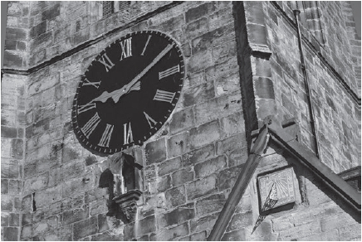
Figure 7
The clock is showing a time of 09:10 GMT while the shadow on the sundial indicates a time of 9 am.
(i) State the Apparent Solar Time when this photograph was taken.
(1)
.............................................................................................................................................
(ii) If the Equation of Time on the day when this photograph was taken was –2 minutes, calculate the Mean Solar Time at this location.
Use the equation:
Equation of Time = Apparent Solar Time – Mean Solar Time
(2)
.............................................................................................................................................
.............................................................................................................................................
.............................................................................................................................................
(iii) Hence show that the longitude of the location where the photograph was taken is 2°W.
(2)
.............................................................................................................................................
.............................................................................................................................................

(Total for question = 5 marks)

