Year 7 Weather and Climate

Lesson 4 - GIS: UK weather and climate

1. Weather and climate have two different meanings. Can you match the feature with the correct word?

Weather | Climate
• Large area • Small area
• Short term • Long term

Go to this link: https://arcg.is/PG8ef
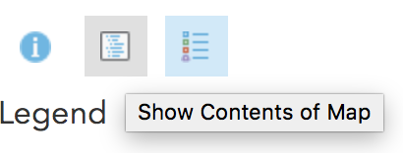
On the left panel click on the middle icon to show the contents of the map.

The map is showing you different climates around the world. Click on the map to find out what each of the colours mean.

2. Can you use the map to describe the climate of the UK? Write it down below.

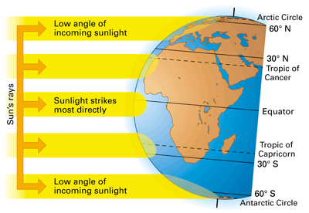

3. Use the diagram above to help explain how the latitude of the UK can influence the climate.

Biomes.

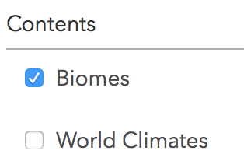
DEFINITION: A Biome is a specific Ecosystem linked to a climate system

To view the world biomes, tick the box left of the biomes layer and untick the box next to the “world climates” layer.

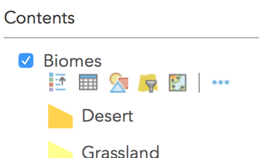
Click the show legend icon to understand what each of the colours mean. Use the maps to help answer the questions below.

4. Can you match the following options to the correct pictures?
Option 1

A desert
- Far north.
- Below freezing for most of the year.
- Ground permanently frozen.
- Light snow.

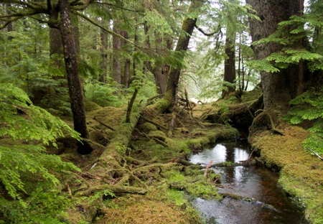
Option 2

A temperate forest
- 23.5° north - 23.5° south of the equator.
- Hot and wet all year.
- Rich in plants and animals.
- Poor soils.
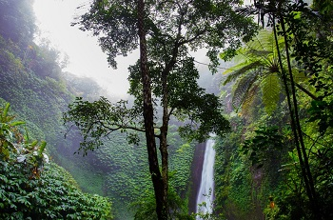
Option 3

A tropical rainforest
- 15-30° north and south of the equator.
- Very hot and dry.
- Limited plants.
Option 4
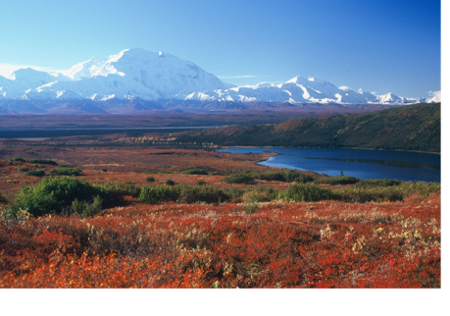
- 40-60° north and south of the equator.

Tundra
- Cool summers and mild winters.
- Rain throughout the year.
- Rich deciduous woodlands

5. Which biome is the UK in?

UK weather and climate.
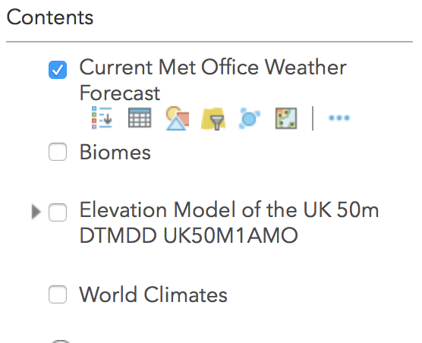
Let’s now look at the UK weather. First zoom in so that you can see the UK only. You can do this by double-clicking on the UK or using the + and – symbol.
Untick all of the other layers and tick the layer “Current Met Office Weather Forecast”.
You should have an image similar to the one below. This is showing the predicted weather forecast at each of the UKs weather monitoring stations.
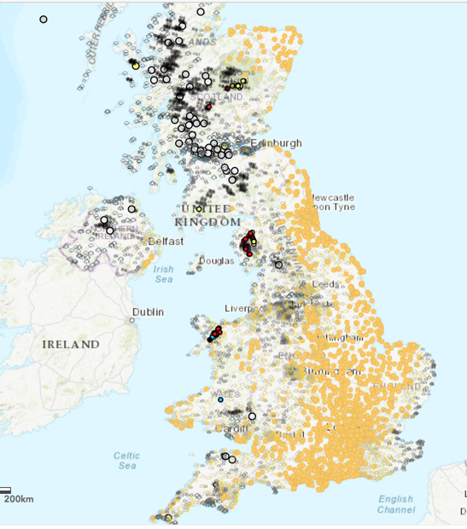
To get a clearer picture of the weather we are going to use the ‘cluster tool”

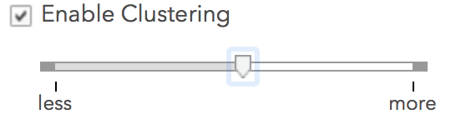
The cluster tool summarises all the nearby data points. By moving the slider to the left and to the right, you are changing the radius of the sphere of influence.

6. Paste a screenshot below and describe the weather forecast for the UK today.

Print this sheet off and draw in the anagram answers.

