Year 7 Weather and Climate

Lesson 1 - Why does it rain?

Read this diagram about three types of rainfall carefully.

Watch this video on rainfall.

Now complete the following questions.

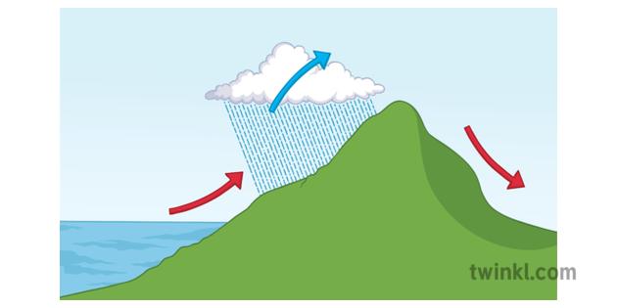
- Describe and explain relief rainfall over mountains (suggested 150 words max)

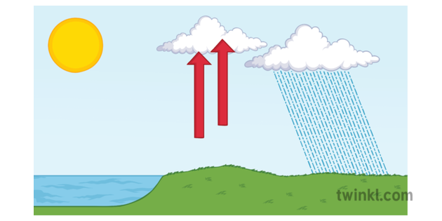
- Describe and explain convectional rainfall (suggested 150 words max)

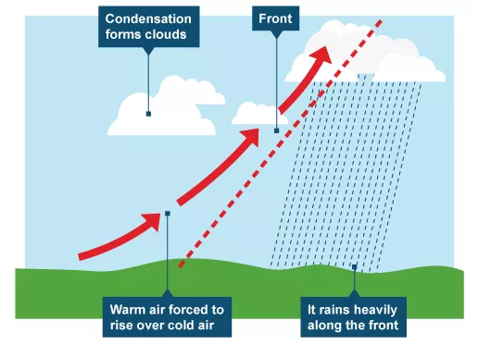
- Describe and explain frontal rainfall when two air masses meet and don’t mix. (suggested 150 words max)

