Year 7 Weather and Climate

Lesson 2 - Air masses

Read the figure below

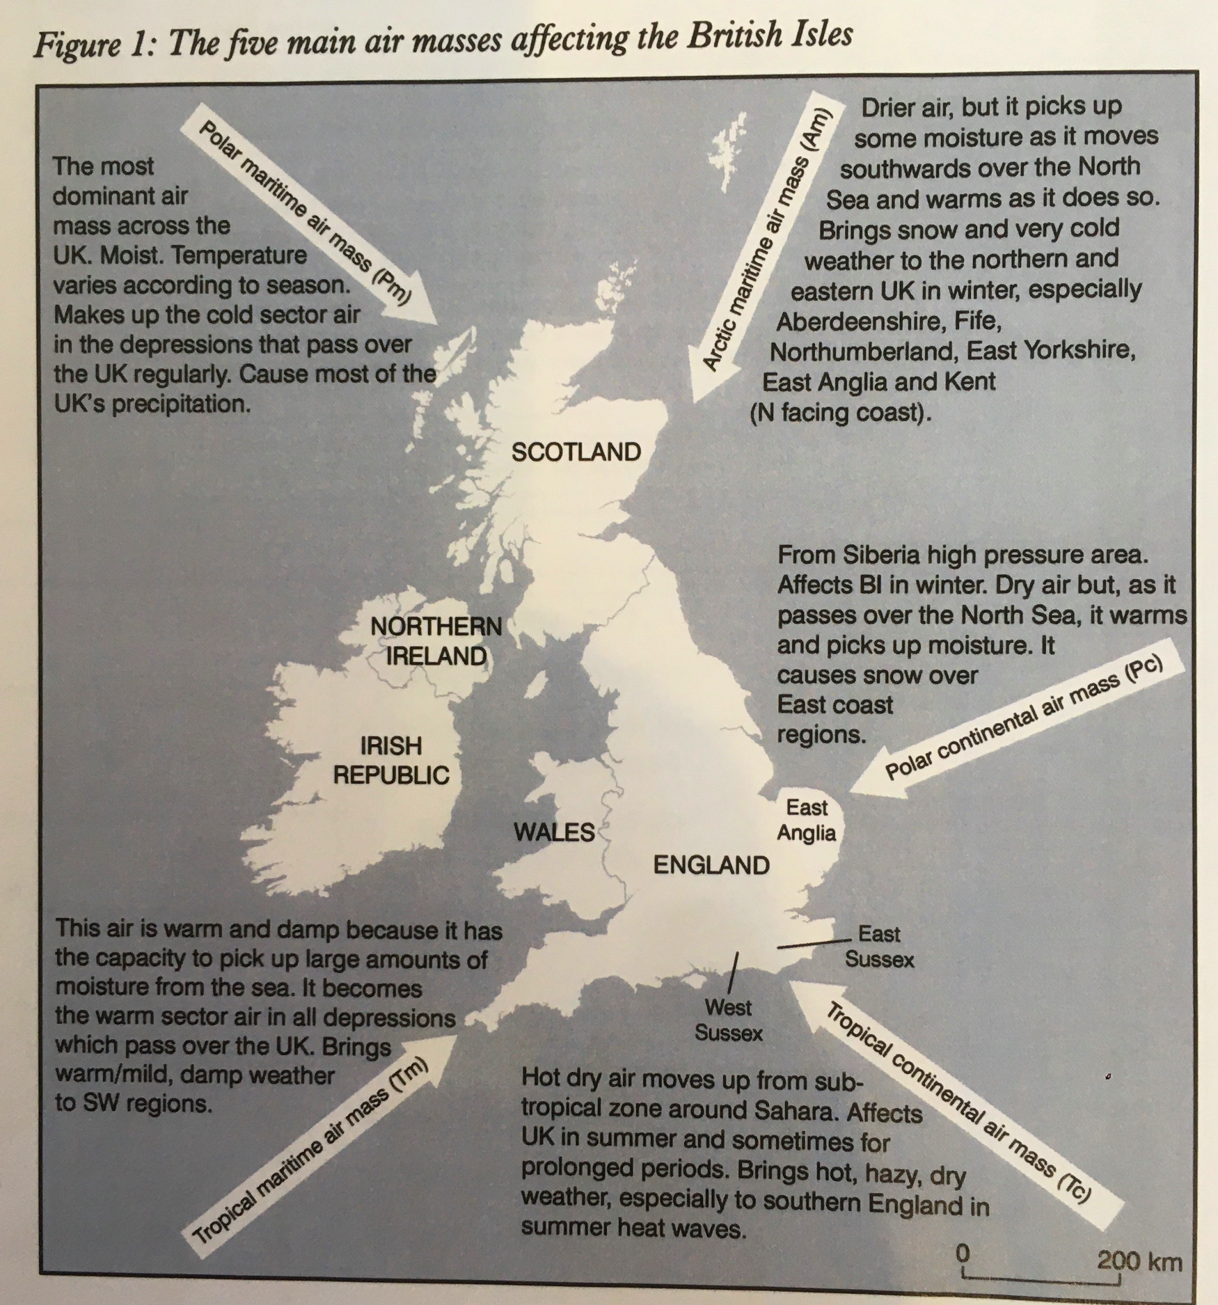

Then start by watching this video (3mins).

Fill in the table below. The first one has been done for you.

 | Where does the air mass originate? | Over what surface does it travel? | Characteristics of this air mass?
Polar Maritime | Polar area | sea | cold and wet
Polar Continental
Tropical Continental
Tropical Maritime

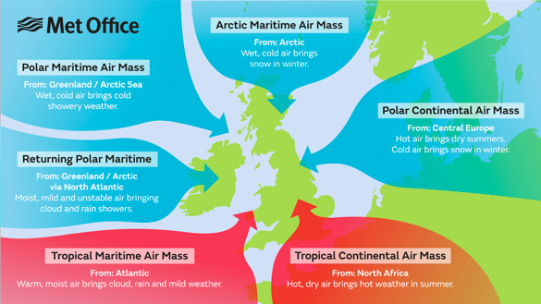

Watch this weather fronts video and answer these questions (2mins)

- What is a weather front?

- What is a warm front like? Bonus - what is the symbol for this? What is the weather like in a warm front?

- What is a cold front like? Bonus - what is the symbol for this?

- How can you measure atmospheric pressure - what instrument is used for this?

- Describe some different types of clouds? Go to google images and add an image of them. Complete the table below to do this. Some have been completed for you.

Cloud type | Description | Insert Image from google here
Cirrus | high altitude clouds, mainly formed of ice | 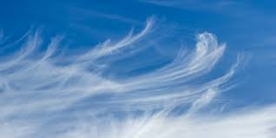
Cumulus

Altostratus

Cumulonimbus

Nimbostratus |  | 