Lesson 5: The Earth’s Motion in Space

Look at this video and watch how each planet rotates on its axis - this causes day and night:

https://www.youtube.com/watch?v=qhJrpzsKEXo (1:30)

Then fill in this table with the names of the seven, other major planets in the correct column:

Days Longer than Earth’s (rotation is slower) | Days Shorter than Earth’s (rotation is faster)

The Earth, and the other planets, also orbit around the Sun. Find out how long each planet takes to orbit the Sun once:
https://nineplanets.org/planets/

Major Planet’s Name | Time to orbit the Sun:
Mercury
Venus
Earth | 365.256 days
Mars
Jupiter
Saturn
Uranus
Neptune

Watch this very clear video explaining why seasons only happen if a planet’s axis is tilted - be prepared to write down the answers to these questions at the appropriate time in the clip:
- What causes seasons? (0:20)
- What is the name given to the point in the Earth’s orbit in March when there is an equal amount of daytime and nighttime on all parts of the Earth? (0:51)
- How many months are there between this point and the June solstice? (1:03)
- What does Earth’s North Pole always point towards? (1:05)
- In June, which hemisphere of the Earth gets most sunlight? (1:14)
- What point is reached three months after the June solstice? (1:22)
- Which parts of the Earth get equal amounts of day and night at the September equinox? (1:35)
- What is the Earth’s North Pole still pointing towards at the December solstice? (1:45)
- Which hemisphere gets much less sunlight at the December solstice? (1:50)
- What does NOT cause the differences in the Earth’s seasons (2:03)

https://www.youtube.com/watch?v=NweLxtmnzv4 (2:23)

Now go back to the first video and look at the different ways in which the axes of the major planets are tilted - remember, if there is a tilt then they will have seasons, if there is no tilt then there will be no seasons, as if there was permanent autumn or spring. Use the video to help you fill in the next table:

https://www.youtube.com/watch?v=qhJrpzsKEXo (1:30)

Major planet’s name | Tilt of its axis (degrees) | Does it have seasons or not?
Mercury
Venus
Earth | 23.4 | Yes
Mars
Jupiter
Saturn
Uranus |  | Good question!
Neptune

Now run the amazing Stellarium planetarium programme to investigate the view of the Sun from the Earth:
https://stellarium-web.org/
(if you want to, and you have permission from the owner of the device you are using, you can download a copy of Stellarium from the website https://stellarium.org/ which can be used offline and has more functions)
Drag the sky around until you are facing S then click on the date box in the bottom right corner and set the date to 21 December (month 12) for the year you are in now and the time to mid-day (12:00:00)
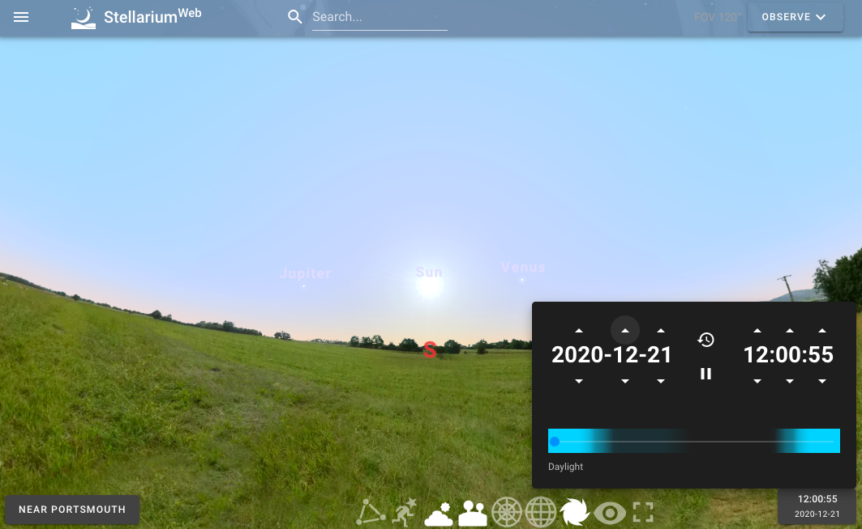
Investigations:
1.Notice where the Sun is in the sky, then click the months ahead, one by one, until June (month 6). Describe what is happening to the Sun’s position:

2. Now use the daylight slider beneath the dates to slide the time ahead until the sun sets (you might need to drag the sky to the W to be sure of when this happens).
- What time does the Sun set on June 22nd?
- Slide the time forward until the Sun rises again (find E) - what time is this on June 21st?
- Return the month setting to December (12) - what time does the Sun set on December 21st?
- What time does the Sun rise on December 22nd?
- Describe the differences in the length of daytime and nighttime between December and June:
- Explain these differences by using the fact that the Earth’s axis is tilted so that different hemispheres get different amounts of daylight at different times of year (you may need to go back to the earlier video for help https://www.youtube.com/watch?v=NweLxtmnzv4

